1. When we use **-V** in “docker run” command, Docker will create some folders on Host Machine without letting us know.
2. **Command** 🡺 docker volume --help:
   1. 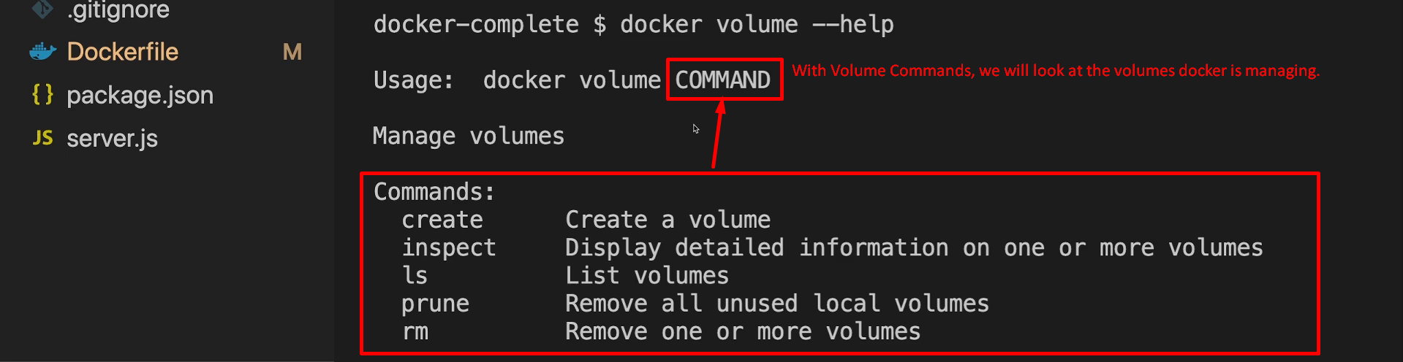
3. Command 🡺 docker volume **ls**
   1. 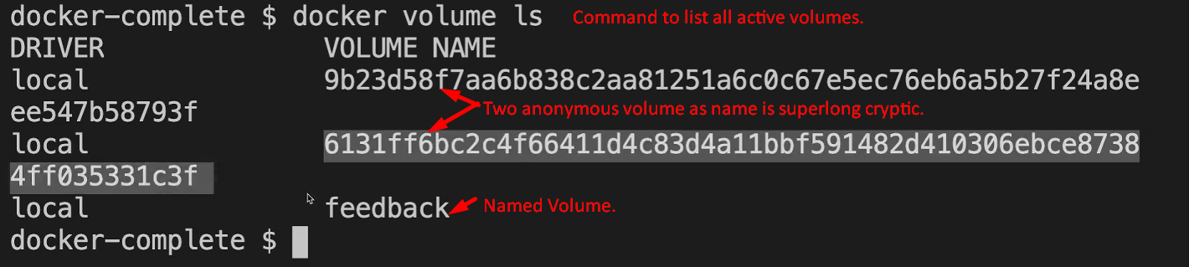  
      **NOTE**: You can’t see Bind Mount volumes with “docker volume ls” as such volumes are not maintained by docker.  
      These volumes are not managed by docker as such volumes are known folder on our host machine and “Managed by Docker” also means that Docker will create this volume if it doesn’t exist yet, when you run a container.
4. Command 🡺 docker volume create –help:
   1. 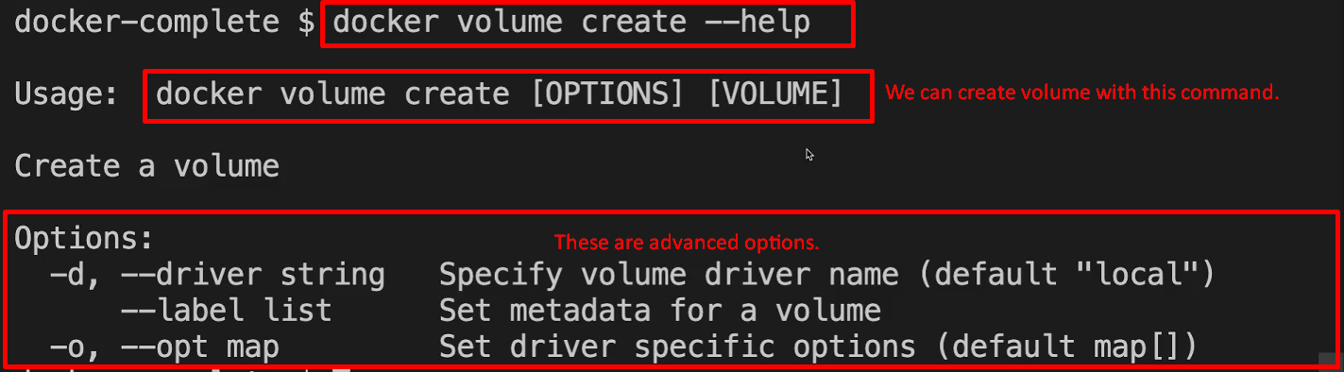
5. **Let’s create a named volume with that command and use it in a container**.
   1. Timeline

      Description automatically generated
6. **Command** 🡺 docker volume inspect <vol_name> 🡸 inspecting volume:
   1. 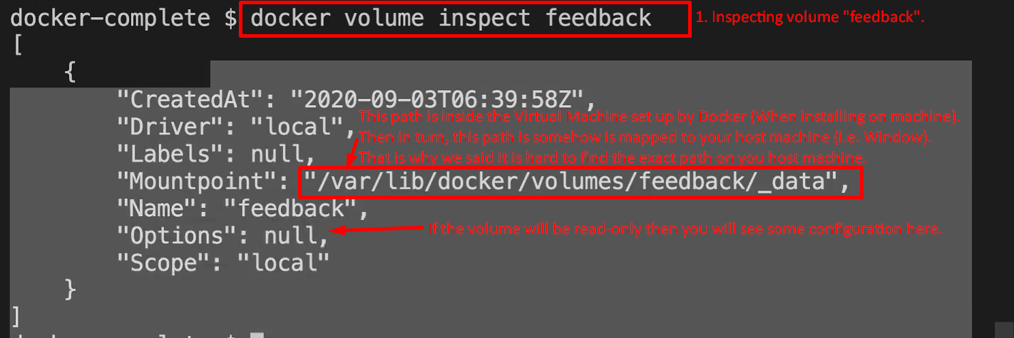
7. **Command** 🡺 docker volume rm <vol_name>
   1. 
   2. 